Supplementary Information 7

C. Louwa, E. Besterb, E. Archerb, F. Kamperc, d, G. M. Wolfaardtb, e T. M. Louwa*

a *Department of Process Engineering, Faculty of Engineering, Stellenbosch University, Stellenbosch, South Africa*

*b Department of Microbiology, Faculty of Science, Stellenbosch University, Stellenbosch, South Africa*

*c Department of Statistics and Actuarial Science, Faculty of Economic and Management Sciences, Stellenbosch University, South Africa*

*d Swiss Data Science Center, EPFL & ETH Zürich, Switzerland*

*e Department of Chemistry and Biology, Faculty of Science, Ryerson University, Toronto, Canada*

*\* Corresponding author:* [*tmlouw@sun.ac.za*](mailto:tmlouw@sun.ac.za)*; Tel: +27 21 808 4051, Department of Process Engineering, Private Bag X1, Matieland, Stellenbosch, 7602, South Africa*

## All AMR incidence reports: Comparison of the 5-fold cross validated R2 values of predicting AMR incidence for the individual microbes vs. all microbes combined.

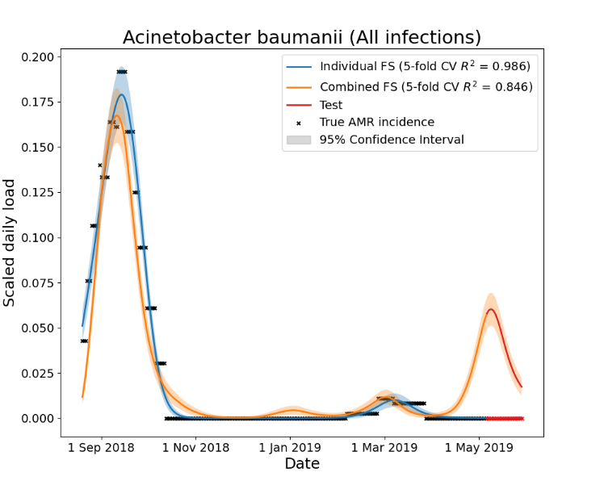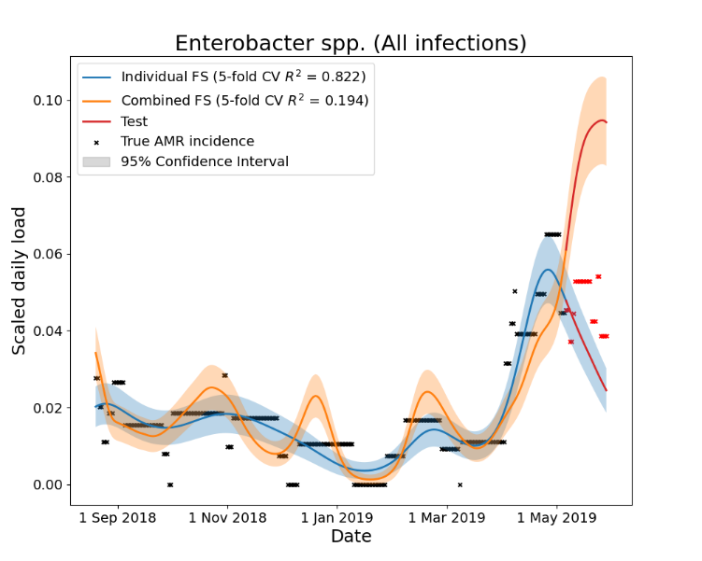

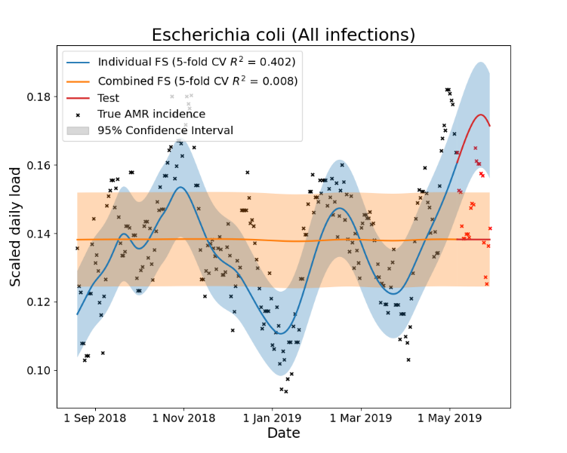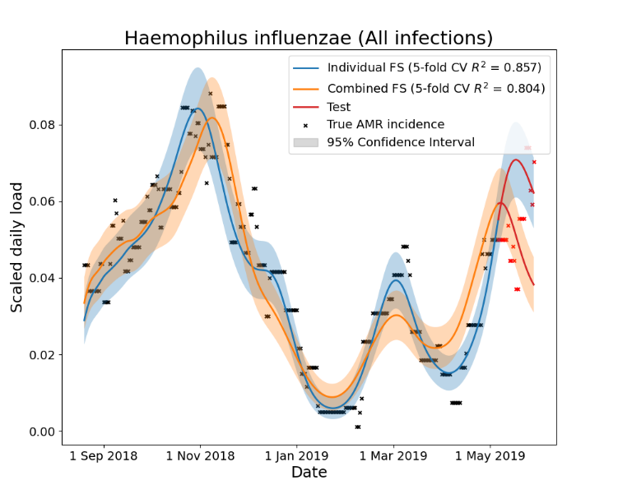

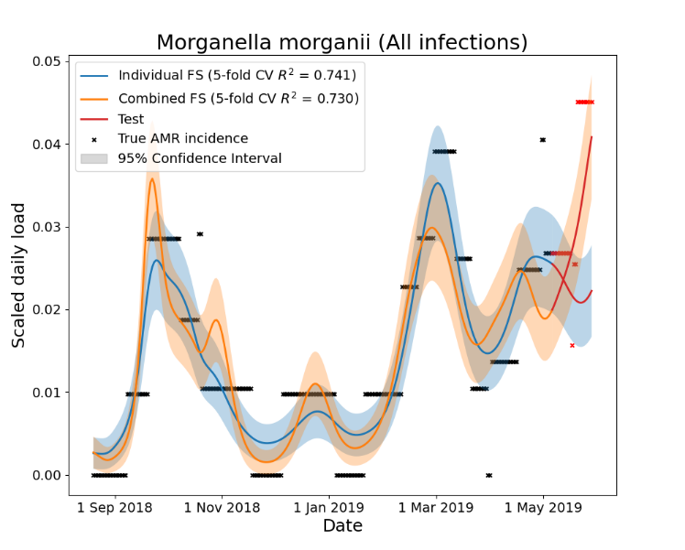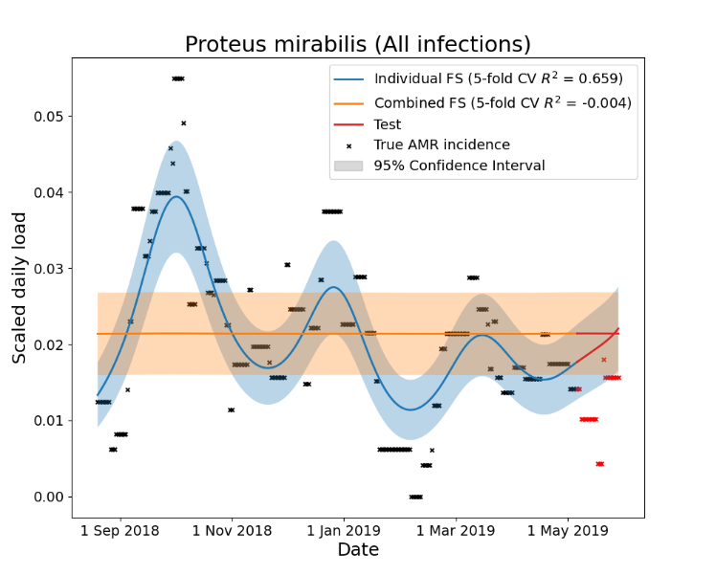

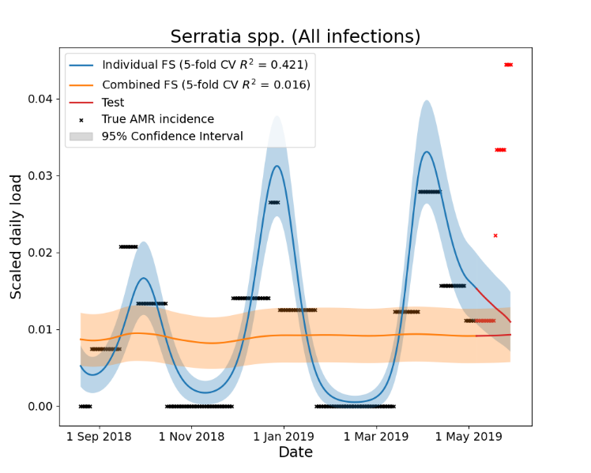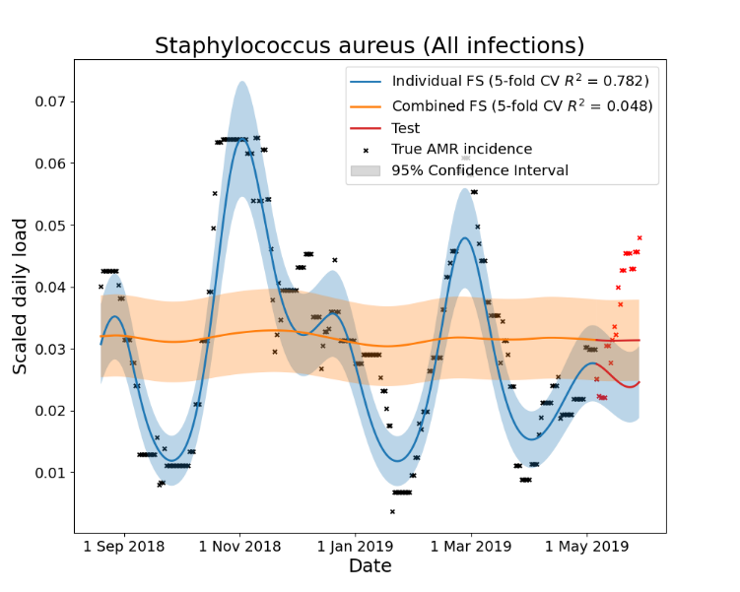

## Hospital acquired infection incidence reports: Comparison of the 5-fold cross validated R2 values of predicting AMR incidence for the individual microbes vs. all microbes combined.

## Community acquired infection incidence reports: Comparison of the 5-fold cross validated R2 values of predicting AMR incidence for the individual microbes vs. all microbes combined.

